1. Introduction and Background
In this report, we explore a classification problem using a probabilistic approach, specifically utilizing the Gaussian Mixture Model (GMM). Classification plays a crucial role in data analysis and machine learning, where we aim to assign labels to data points based on their features. The GMM is a probabilistic model that assumes that data points are generated from a mixture of several Gaussian distributions with unknown parameters.
We combine the GMM with the Bayes Classifier to classify data into multiple classes by estimating the parameters (mean, covariance, and weights) of the Gaussian components using the Expectation-Maximization (EM) algorithm. This approach is particularly powerful because GMMs can model data that arises from multiple sub-populations, each represented by a Gaussian distribution. The decision boundaries between classes are visualized to observe how well the classifier separates the data points.
2. Methods
2.1. Gaussian Mixture Model (GMM)
The GMM assumes that data points are generated from a mixture of multiple Gaussian distributions, each with its own mean, covariance matrix, and a mixing coefficient (weight). The goal is to find the parameters of these Gaussians such that they best fit the observed data.
- Parameters of GMM:
  - Means: The center of each Gaussian component.
  - Covariance matrices: Describe the shape and orientation of each Gaussian component.
  - Weights: The mixing coefficients that indicate the relative contribution of each Gaussian component to the data.
The GMM's parameters are estimated using the Expectation-Maximization (EM) algorithm, which iteratively refines the estimates of the parameters. The EM algorithm consists of two steps:
- Expectation (E-step): Given the current parameters, compute the responsibility that each Gaussian component takes for each data point.
- Maximization (M-step): Update the parameters of the Gaussian components (means, covariances, and weights) based on the computed responsibilities.

2.2. Bayes Classifier
The Bayes Classifier is used to classify new data points based on posterior probabilities. For each class, we assume the data is generated from a mixture of Gaussians, and we calculate the posterior probability of each class given the observed data. A new data point is classified into the class with the highest posterior probability.
The classification process involves:
- Training: Estimating the GMM parameters for each class using the training data.
- Prediction: For each test data point, the probability of belonging to each class is computed, and the class with the highest probability is assigned.
2.3. Decision Boundary Visualization
To better understand the performance of the classifier, we visualize the decision boundaries in the feature space. Decision boundaries represent the regions in the feature space where the classifier changes its prediction from one class to another. These boundaries are generated by evaluating the posterior probabilities for each class over a grid of points that span the feature space. Each point is colored according to the class with the highest posterior probability, resulting in a visual depiction of the regions assigned to each class.

3. Observations and Results
3.1. Log-Likelihood Convergence
For each GMM, the log-likelihood is tracked over iterations of the EM algorithm. The log-likelihood is a measure of how well the current parameters of the GMM explain the observed data. As the EM algorithm iterates, the log-likelihood typically increases and eventually converges, indicating that the parameters have stabilized.
Across different experiments with varying numbers of Gaussian components (K), we observe:
- Rapid Convergence: The log-likelihood tends to converge within a small number of iterations, showing that the EM algorithm is efficient in finding the optimal parameters.
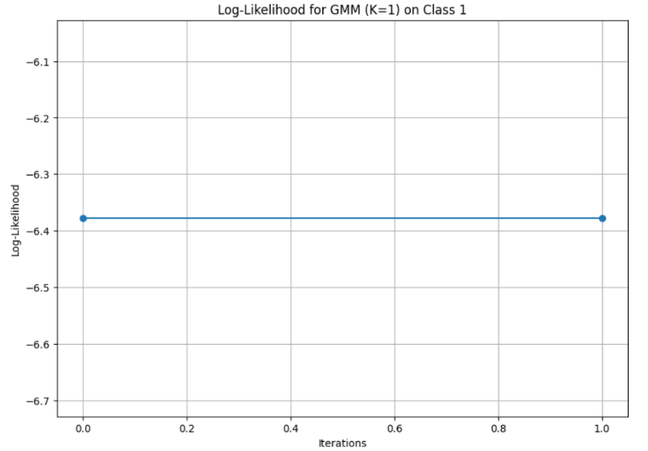
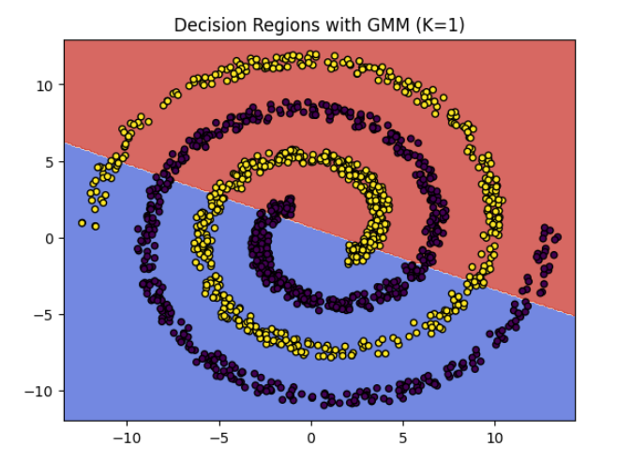
- Higher K: As the number of Gaussian components increases, the GMM can fit more complex data distributions, but the risk of overfitting also increases. This is observed in cases where the log-likelihood increases but the decision boundaries become overly complex.
Figure 2 Log Likelihood for GMM K=1
Figure 1 Decision Regions with GMM, K=1

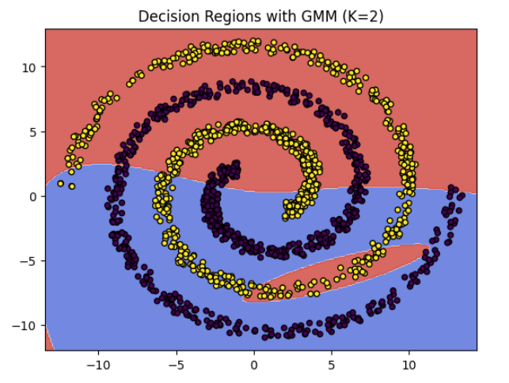
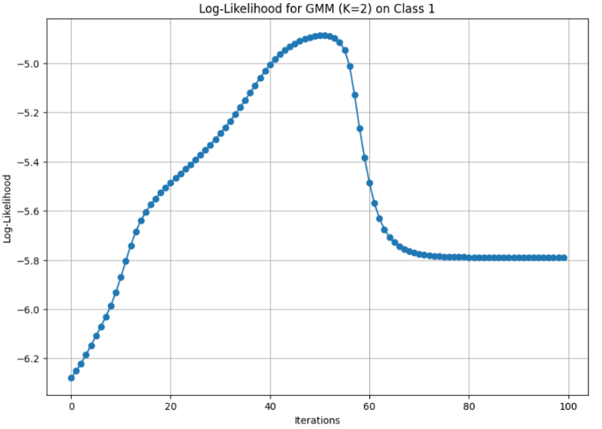
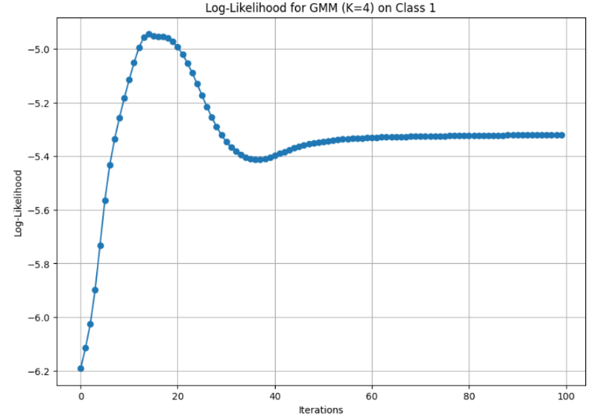
Figure 3 Log Likelihood for GMM K=2
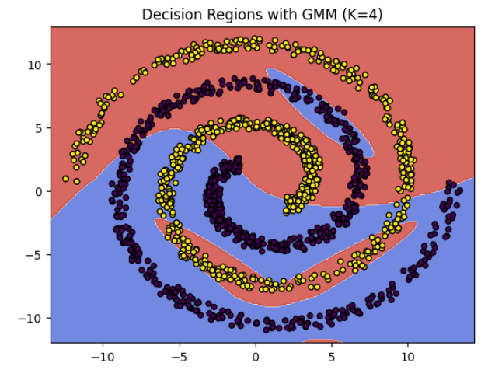

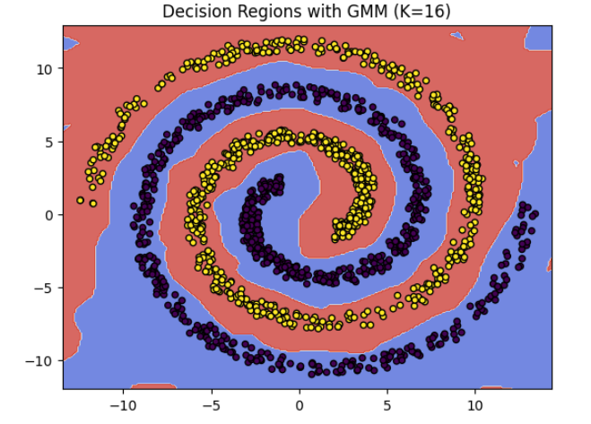
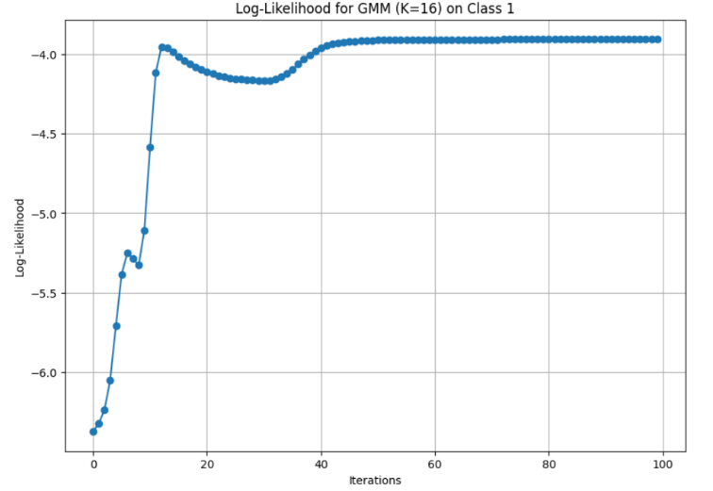
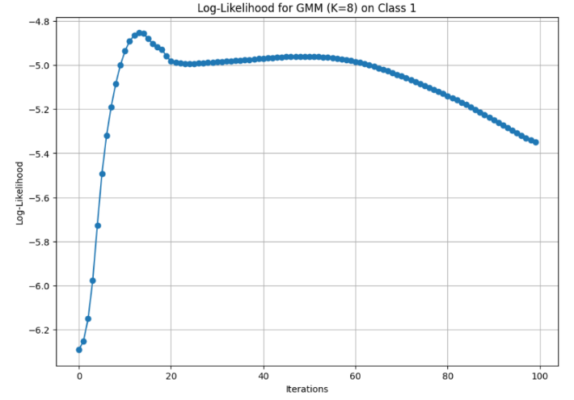
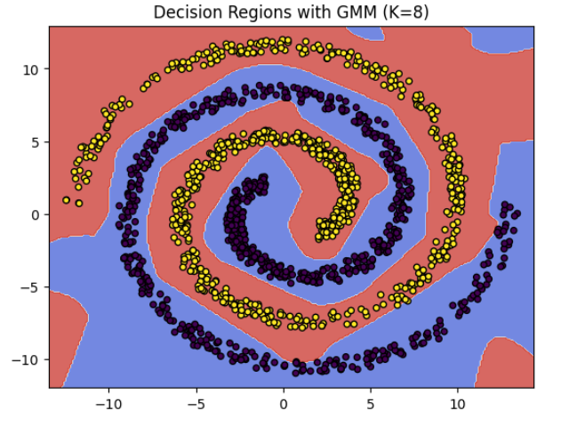
for K=16...
Confusion Matrix:
[[735. 0.]
[ 0. 734.]]
Accuracy: 1.0000
Precision: 1.0000
Recall: 1.0000
F1-Score: 1.0000 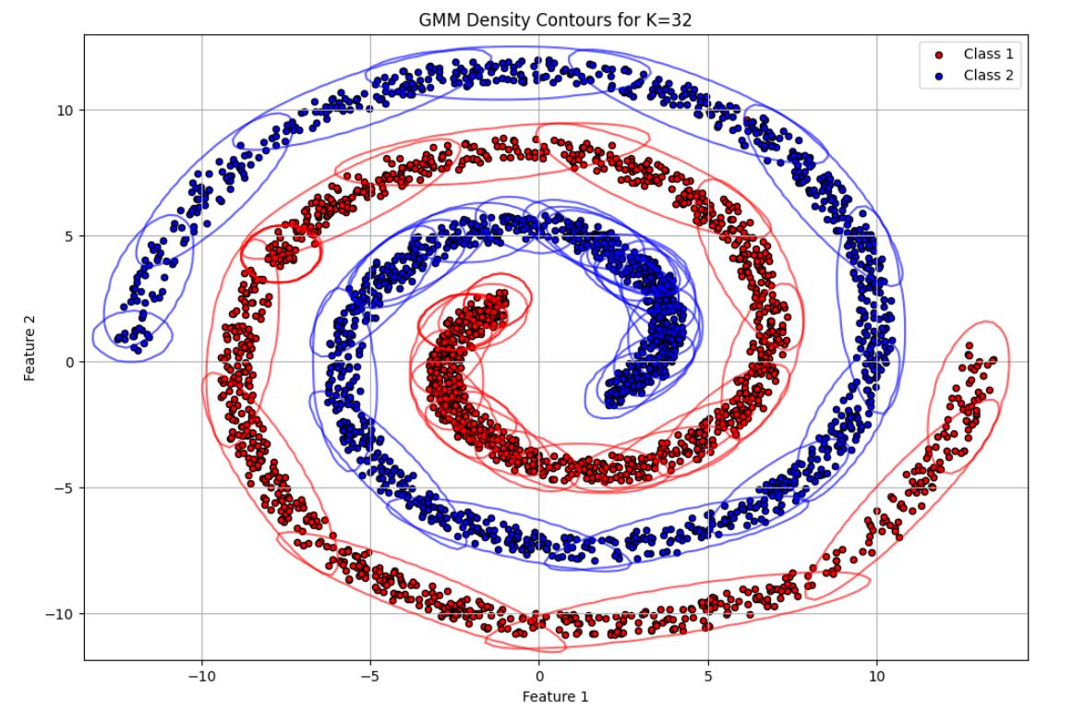

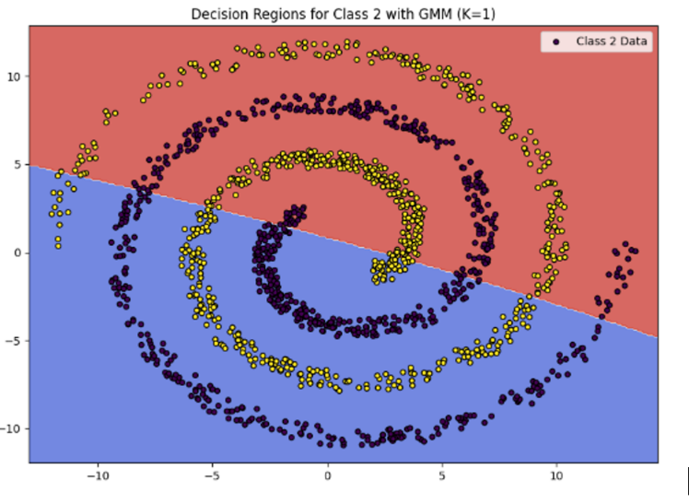
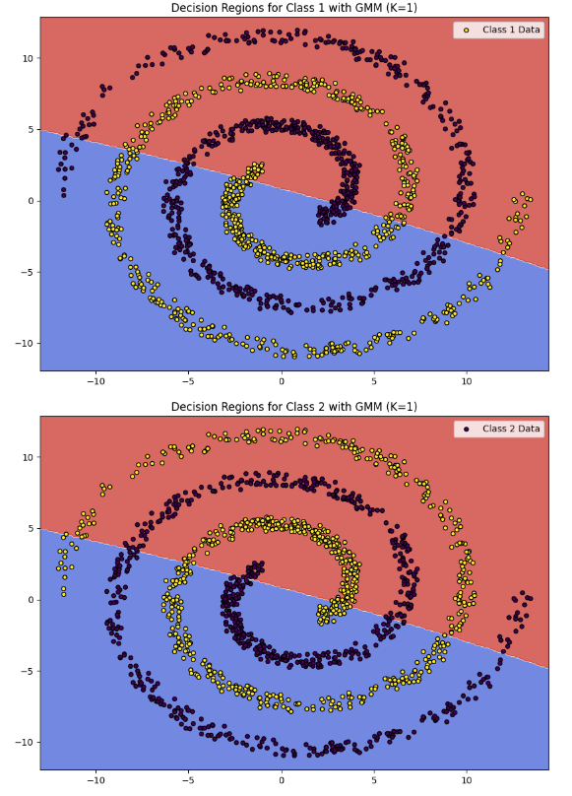

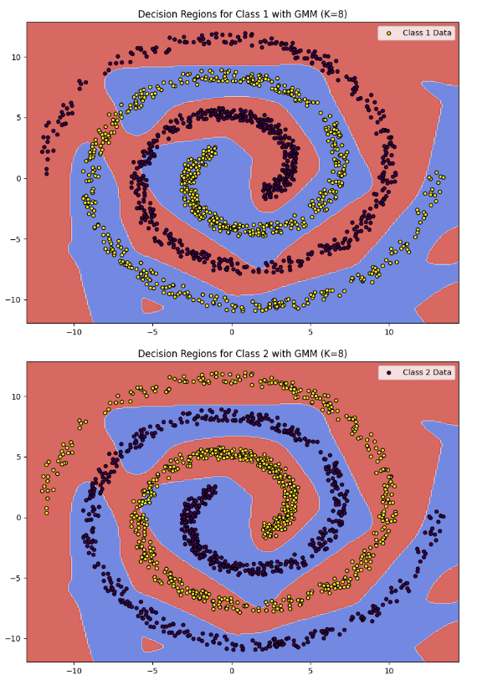
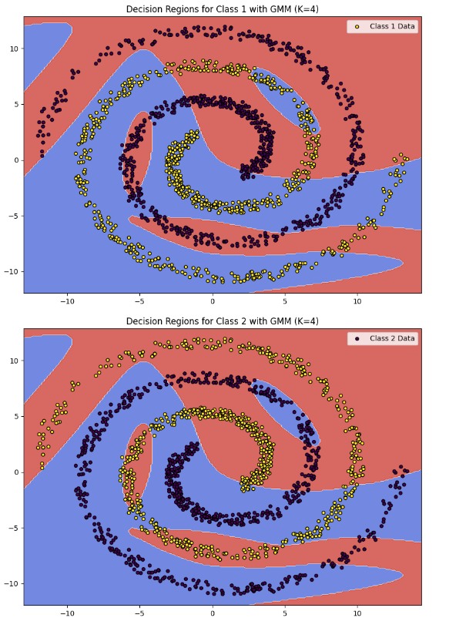
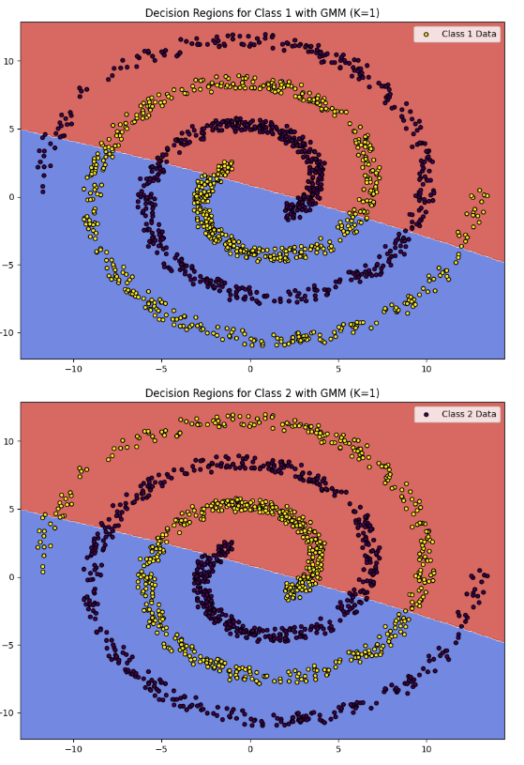
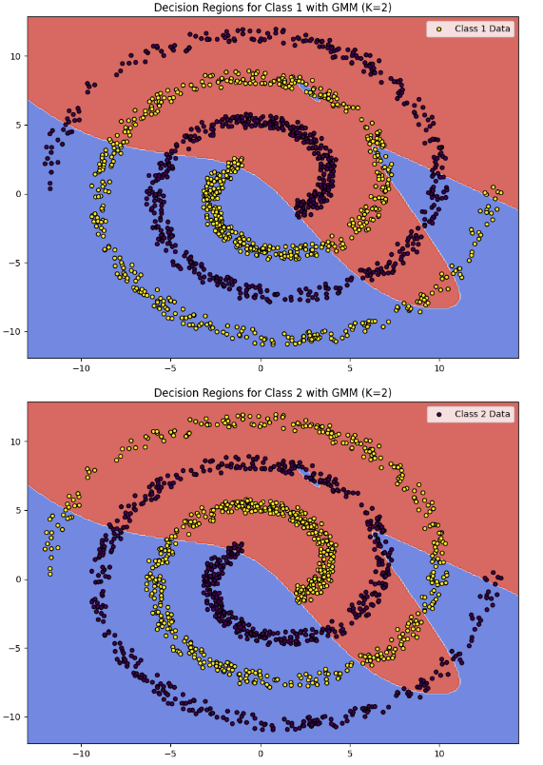
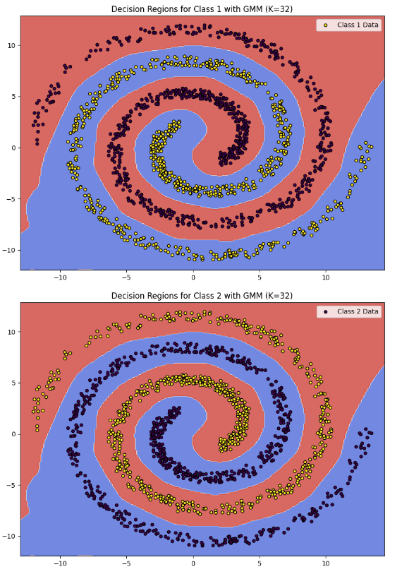

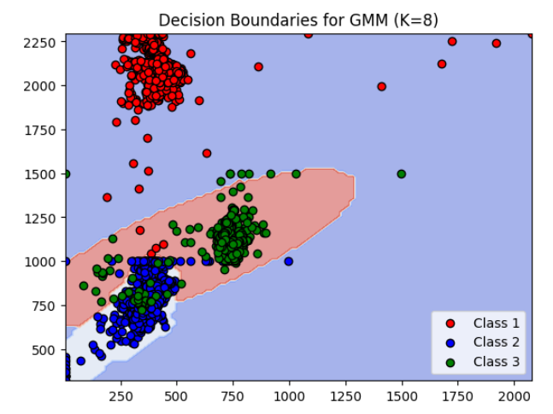
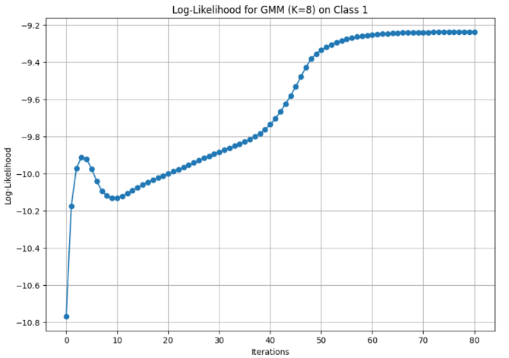
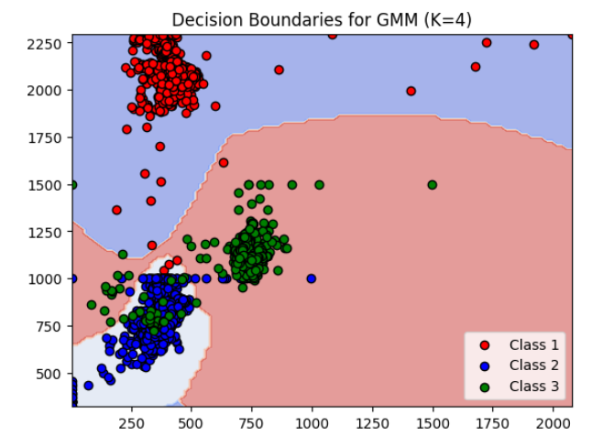
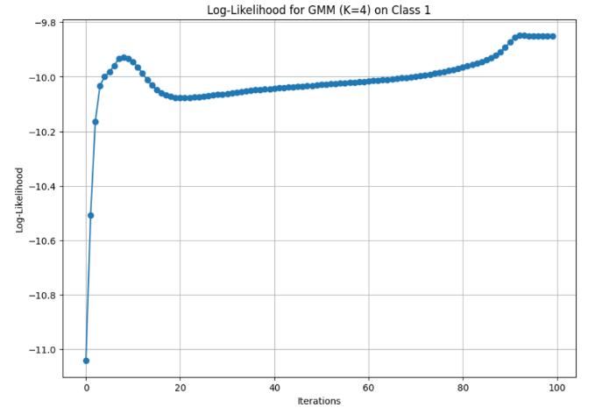
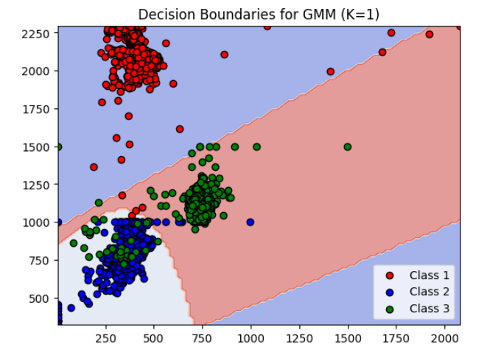
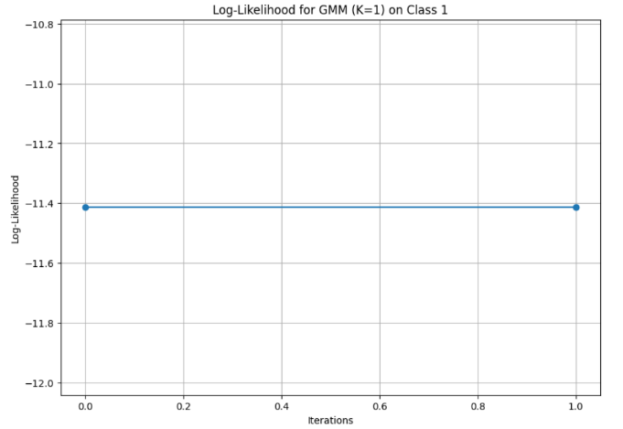
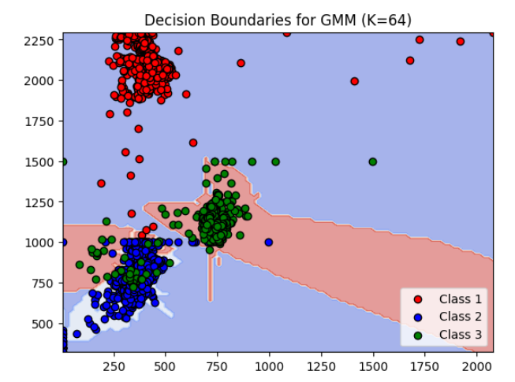
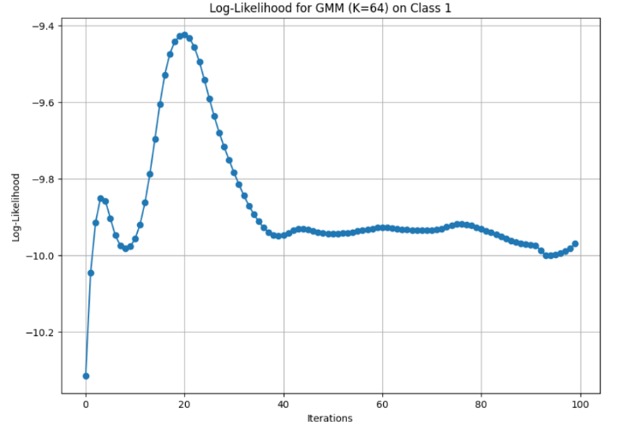
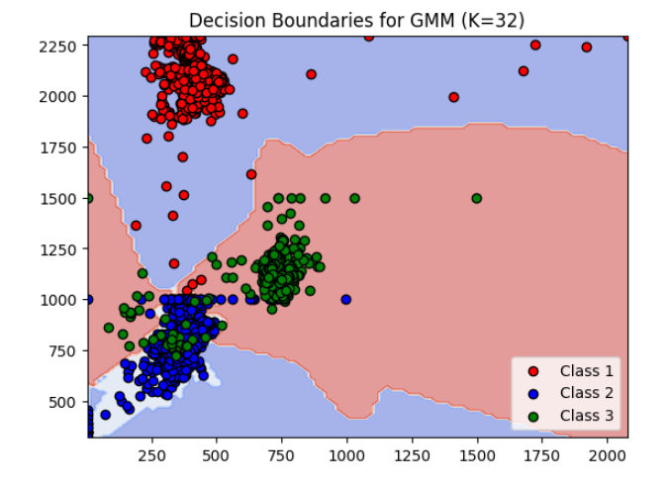
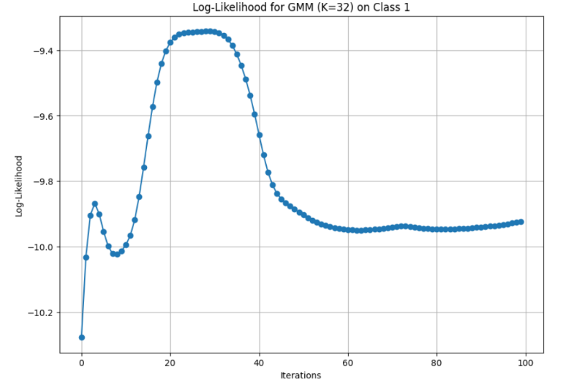
3.2. Decision Boundaries for Different K Values
The decision boundaries were plotted for various values of K (the number of Gaussian components per class). These boundaries show how the classifier separates the classes based on the posterior probabilities estimated by the GMM.
- K = 1 (Single Gaussian): For each class, the data is modeled by a single Gaussian. The decision boundaries are relatively simple and roughly linear, as each class is represented by an ellipsoidal region. This works well when the data points for each class are clustered around a single center.
- K = 2, 4 (Multiple Gaussians): With an increase in K, the decision boundaries become more complex and non-linear. This allows the GMM to better capture the variability within each class, especially when data points are spread out or have multiple clusters within the same class.
- K = 8 or higher: As K increases further, the decision boundaries start to become very intricate, capturing fine-grained details in the data. However, this can lead to overfitting, where the model starts to capture noise in the data rather than the underlying distribution.
3.3. Classification Performance
For each experiment, the classifier’s performance was evaluated using metrics such as accuracy, precision, recall, and the F1-score. A confusion matrix was also computed to assess how well the classifier distinguishes between the different classes.
- Higher K generally improves accuracy: As K increases, the model can represent more complex data distributions, leading to improved accuracy. However, this improvement is marginal after a certain point, indicating diminishing returns from increasing model complexity.
- Trade-off between simplicity and accuracy: For smaller values of K, the classifier is simple and fast, but its accuracy may be lower. For larger values of K, the accuracy improves, but the model becomes more complex and risks overfitting.
3.4. Confusion Matrix
The confusion matrix provides insights into the classifier's performance for each class:
- Diagonal dominance: For well-separated classes, the confusion matrix has a strong diagonal, indicating that the majority of test points are correctly classified.
- Off-diagonal elements: These represent misclassifications, where the classifier confuses one class for another. As K increases, the off-diagonal elements tend to decrease, suggesting improved classification performance.
4. Inference
Based on the experiments and observations, the following inferences can be drawn:
- Effectiveness of GMM with Bayes Classifier: The GMM-based Bayes classifier is a powerful tool for classifying data, especially when the data for each class is generated from multiple sub-populations. The ability to model each class with a mixture of Gaussians allows for flexible decision boundaries that can capture complex data distributions.
- Optimal Number of Gaussians: The choice of K (the number of Gaussian components) is critical. For small values of K, the decision boundaries are simple and may not fully capture the complexity of the data, leading to lower accuracy. For larger values of K, the decision boundaries become more intricate, but the model may overfit. Thus, there is a trade-off between model complexity and generalization.
- Visualizing Decision Boundaries: The decision boundaries provide an intuitive understanding of how the classifier is partitioning the feature space. Simple, linear boundaries are observed for small K values, while highly non-linear and complex boundaries emerge as K increases. This visualization is crucial for interpreting the classifier’s behavior and diagnosing issues like overfitting.
- Scalability and Practical Considerations: Although increasing K improves accuracy, the computational cost also increases. In practice, the choice of K should balance model complexity, accuracy, and computational efficiency.
5. Conclusion
In conclusion, the GMM-based Bayes classifier provides a flexible and effective method for classifying data, particularly when the underlying distribution of each class is complex. By using the EM algorithm, the classifier can model each class as a mixture of Gaussian distributions, resulting in non-linear decision boundaries that adapt to the data. However, careful tuning of the number of Gaussian components is necessary to prevent overfitting and to ensure the model generalizes well to unseen data.

